GR9677 1-10

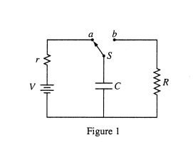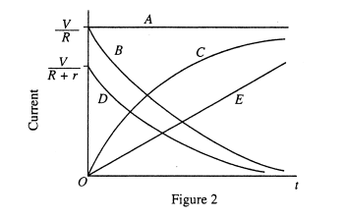
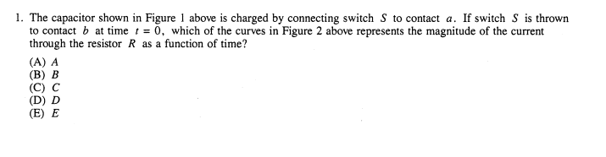

Once the battery is out we have a cap discharging (decay) through R alone. Answer B

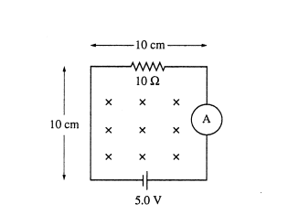

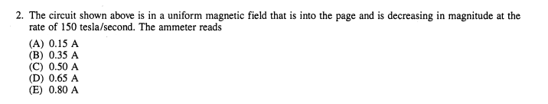

Induced emf opposes battery emf here—do RHR.

(5-150*0.01)/10 ohms=0.35A answer B

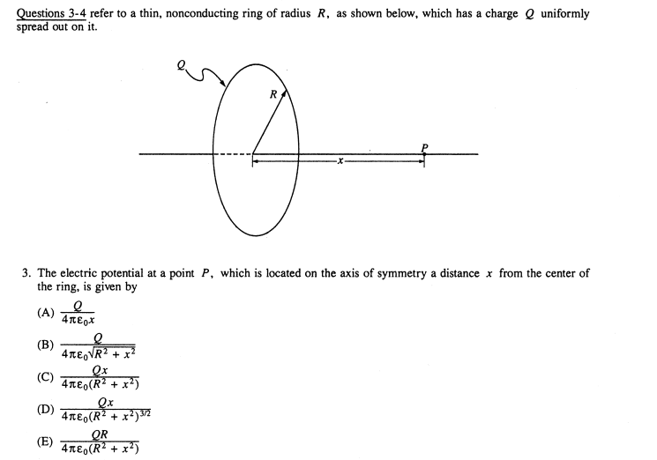

All the elements of charge are a distance of sqrt(R^2+x^2) Answer B.

Note magnitude of E field is given by part D Where x/distance is the appropriate trig function.

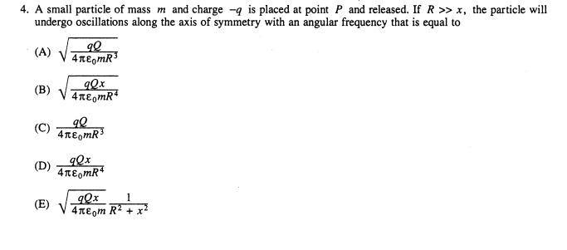

Use answer for D above. Force =q*answer in D above. For small x, this must act like mass on spring. Q*answer in d =kx. Cancel the x to identify k.

Omega =sqrt(k/m) drop x in denom since R>>x. answer A

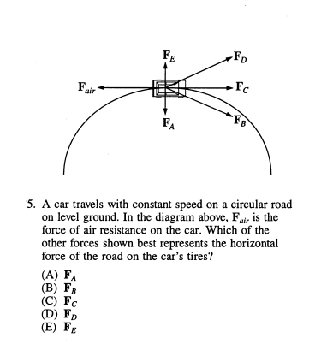

Without air resistance A would be the answer. That provides the inward centrip force.

However with air resistance the road must cancel out the drag force, so FC plus Fair, answer FB---answer B.

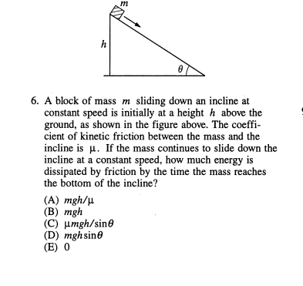

No change in KE, so all work done by the Earth to pull down, must be dissipated by friction work (since none goes to KE).
So “mgh”.
Answer B

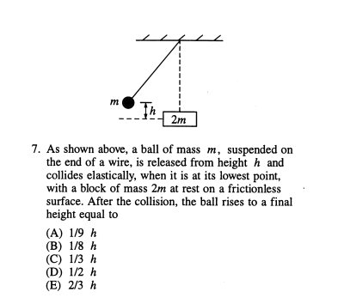
Must solve conservation of momentum and KE.
V1(bot)=sqrt(2gh)

M*V1(bot)= ---M V1+(2M)V2

And

KE 1(bot)=KE1+KE 2

2 eqs, 2unknowns, then back to finding height. No way I would spend this time –unless I come back to it.

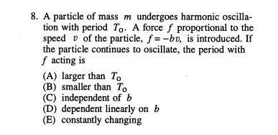

Damping makes the system return slower. Longer time. Answer A.

Sketch exponential damping. Peaks with higher amplitude are shifted to left more than the peaks with smaller amplitude----so timing between each is larger.

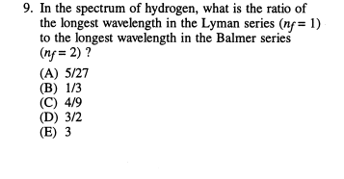

Longest wavelength is smallest energy.

Lyman n=2 to n=1.
Balmer n=3 to n=2

Ratio of energies is (1/2^2-1/1^2)/(1/3^2-1/2^2)

Invert for wavelengths. Answer A. Do it.

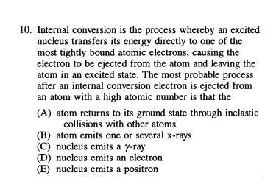

Inner bound electrons have x ray energies. Answer B.

